EXPERIMENT NO-20: PLANETS DB
Aim
To implement a Prolog database that stores information about planets (name, distance from the sun, and diameter), and allows queries to retrieve planetary details.
Algorithm
- Define facts in the database using planet(Name, DistanceFromSun, Diameter).
- Store multiple entries for different planets.
- Write queries to:
  - Find the distance of a planet from the sun.
  - Find the diameter of a planet.
  - List all planets.
- Execute queries to display results.
Prolog Code
prolog
% Planets Database

% Facts: planet(Name, DistanceFromSun in million km, Diameter in km)
planet('Mercury', 57.9, 4879).
planet('Venus', 108.2, 12104).
planet('Earth', 149.6, 12742).
planet('Mars', 227.9, 6779).
planet('Jupiter', 778.5, 139820).
planet('Saturn', 1434, 116460).
planet('Uranus', 2871, 50724).
planet('Neptune', 4495, 49244).

% Rule: Get distance of a planet
get_distance(Name, Distance) :-
planet(Name, Distance, _).

% Rule: Get diameter of a planet
get_diameter(Name, Diameter) :-
planet(Name, _, Diameter).

% Rule: List all planets
list_planets(Name) :-
planet(Name, _, _).
Output
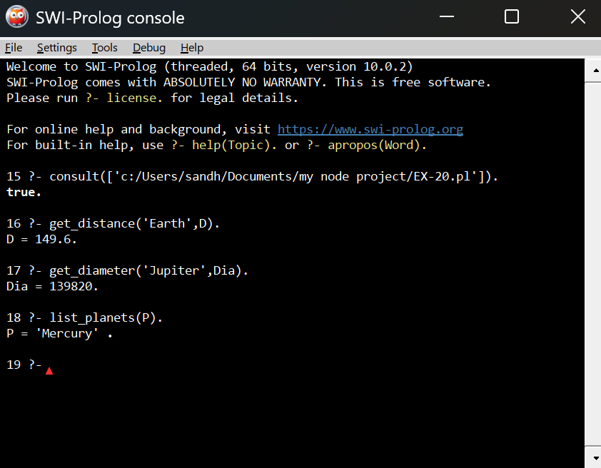
Result
The Prolog program successfully stores planetary data and allows queries to retrieve information such as distance from the sun, diameter, and listing all planets.

